NST21022 - Practical for Network Switching and Routing
Department of Information and Communication Technology
Faculty of Technology
Lab sheet :05
Reg. Number: SEU/IS/20/ICT/084
Academic Year :2020/2021
Practical No :05
Title: Internet Protocol version 4 (IPv4) Subnet
Aim:
• IP addressing scheme.
• Getting familiar with IPv4 subnets
• Configure devices with IPv4 after subnetting.

Task:
• Design an IP scheme.
• Subnet the IPv4 address
• Assign IP addresses to Network devices and verify connectivity
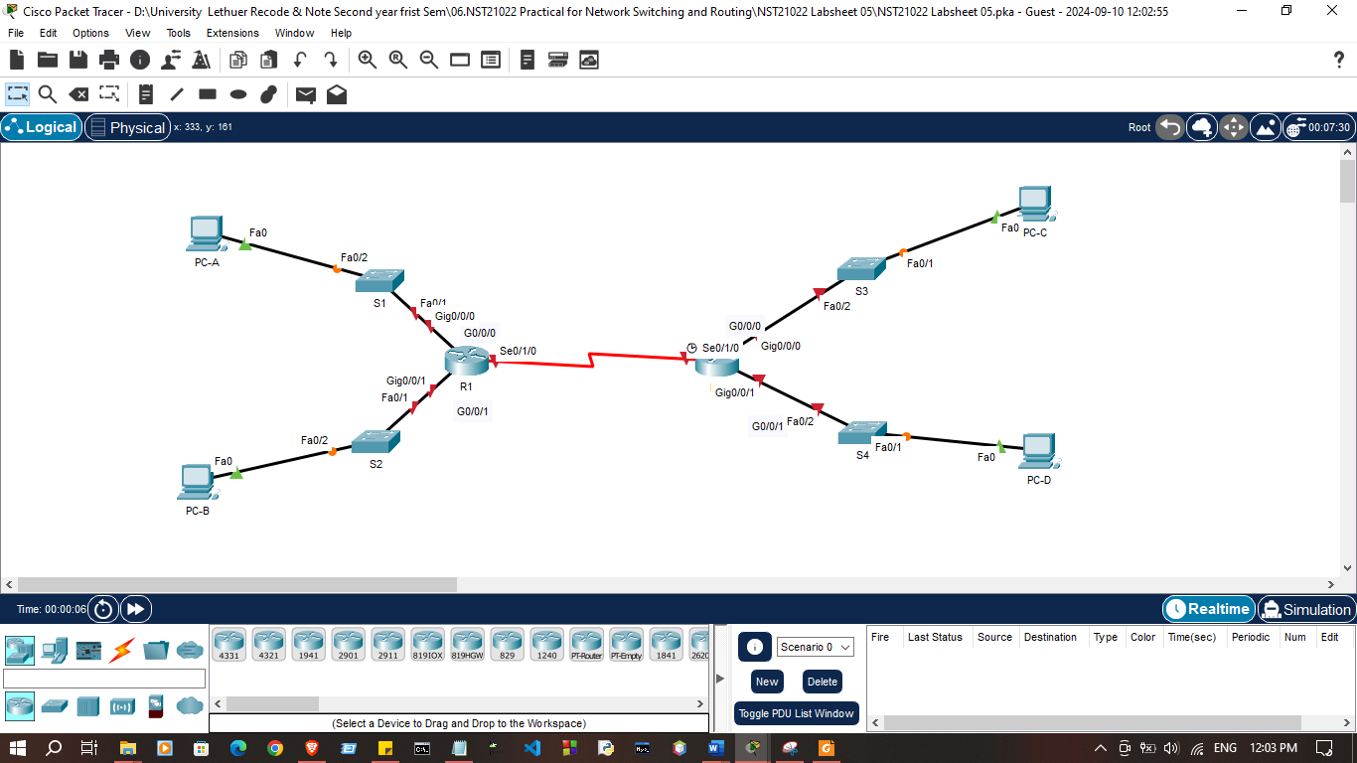
Use “NST21022 Lab sheet 05.pka” file

Activities
Exercise 01:
Subnet the 192.168.1.0/24 network to the appropriate number of subnets.
- Based on the topology, how many subnets were needed?

- 5 subnets

2. How many bits must be borrowed to support the number of subnets in the topology table?

- 3 bit

3.How many subnets does this create?

- 8 subnets
Exercise 02: Fill the subnet table.
 | Network Address | First Usable Host Address | Last Usable Host Address | Broadcast Address
  Subnet Number
1 | 192.168.1.0 | 192.168.1.1 | 192.168.1.30 | 192.168.1.31
2 | 192.168.1.32 | 192.168.1.33 | 192.168.1.62 | 192.168.1.63
3 | 192.168.1.64 | 192.168.1.65 | 192.168.1.94 | 192.168.1.95
4 | 192.168.1.96 | 192.168.1.97 | 192.168.1.126 | 192.168.1.127
5 | 192.168.1.128 | 192.168.1.129 | 192.168.1.158 | 192.168.1.159
6 | 192.168.1.160 | 192.168.1.161 | 192.168.1.190 | 192.168.1.191
7 | 192.168.1.192 | 192.168.1.193 | 192.168.1.222 | 192.168.1.223
8 | 192.168.1.224 | 192.168.1.225 | 192.168.1.253 | 192.168.1.254

Exercise 03: Configure IP address according to following criteria.
1. Assign the subnets to the network shown in the topology.
a. Assign Subnet 1 to the LAN connected to the GigabitEthernet 0/0/0 interface of R1:

Router(config-if)#
Router(config-if)#interface g0/0/0
Router(config-if)#ip address 192.168.1.1 255.255.255.224
Router(config-if)#no shutdown
Router(config-if)#
%LINK-5-CHANGED: Interface GigabitEthernet0/0/0, changed state to up
%LINEPROTO-5-UPDOWN: Line protocol on Interface GigabitEthernet0/0/0, changed state to up

b. Assign Subnet 2 to the LAN connected to the GigabitEthernet 0/0/1 interface of R1:

Router(config-if)#interface g0/0/1
Router(config-if)#ip address 192.168.1.33 255.255.255.224
Router(config-if)#no shutdown
Router(config-if)#
%LINK-5-CHANGED: Interface GigabitEthernet0/0/1, changed state to up
%LINEPROTO-5-UPDOWN: Line protocol on Interface GigabitEthernet0/0/1, changed state to up

c. Assign Subnet 3 to the LAN connected to the GigabitEthernet 0/0/0 interface of R2:

Router(config)#
Router(config)#interface g0/0/0
Router(config-if)#ip address 192.168.1.65 255.255.255.224
Router(config-if)#no shutdown

d. Assign Subnet 4 to the LAN connected to the GigabitEthernet 0/0/1 interface of R2:

Router(config-if)#interface g0/0/1
Router(config-if)#ip address 192.168.1.97 255.255.255.224
Router(config-if)#no shutdown

Router(config-if)#
%LINK-5-CHANGED: Interface GigabitEthernet0/0/1, changed state to up

e. Assign Subnet 5 to the WAN ling between R1 to R2:

Router(config-if)#interface s0/1/0
Router(config-if)#ip address 192.168.1.129 255.255.255.224
Router(config-if)#no shutdown
%LINK-5-CHANGED: Interface Serial0/1/0, changed state to down

Router(config-if)#interface s0/1/0
Router(config-if)#ip address 192.168.1.158 255.255.255.224
Router(config-if)#no shutdown

2. Fill the addressing table using following guidelines:
a. Assign the first usable IP addresses in each subnet to R1 for the two LAN link and WAN link.
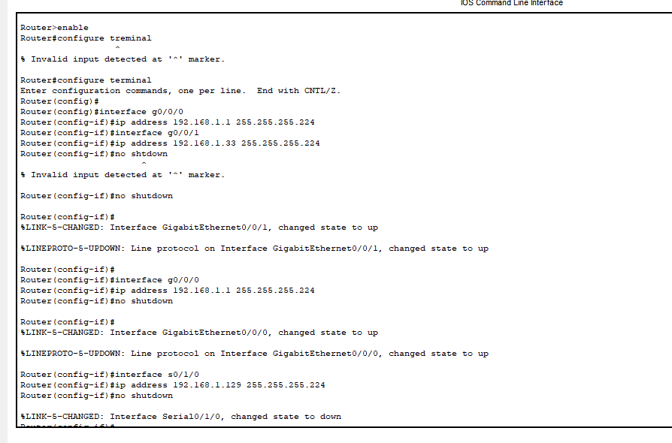
b. Assign the first usable IP addresses in each subnet to R2 for the LAN links, assign the last usable IP address for the WAN link.
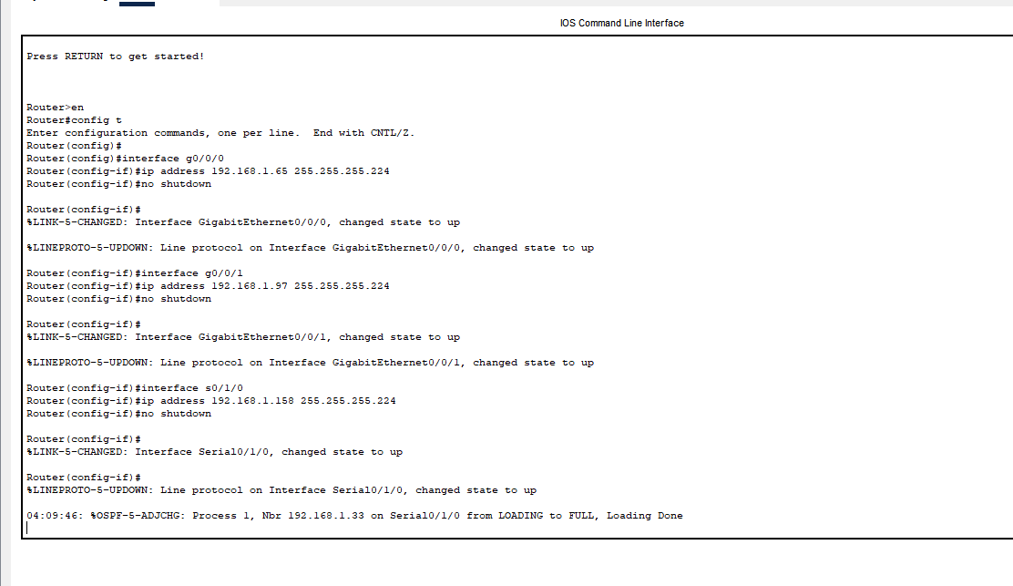
c. Assign the second usable IP address in the attached subnets to the switches.

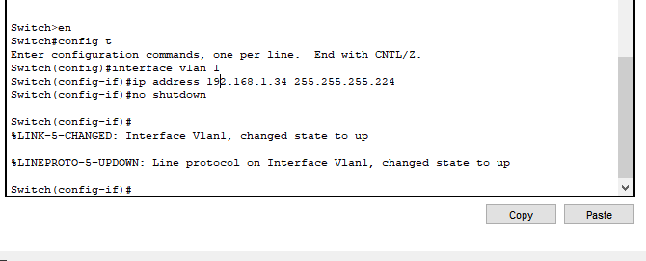
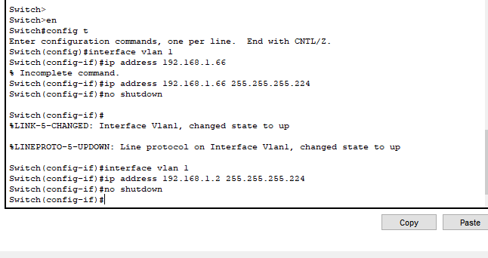

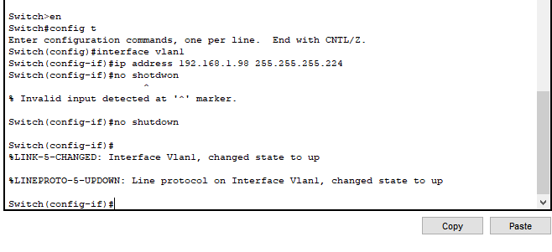
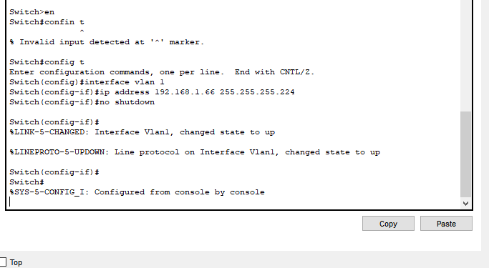

d. Assign the last usable IP address to the PCs in each subnet

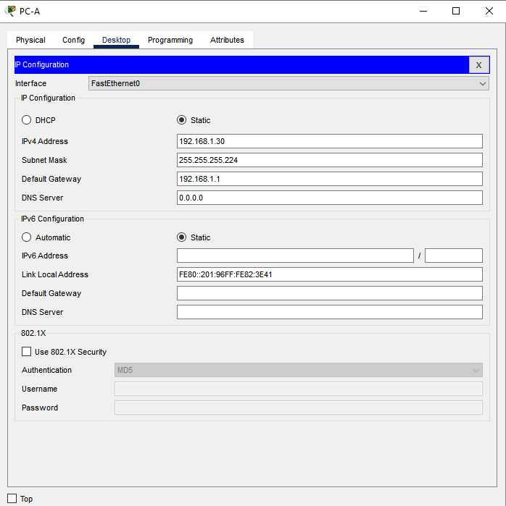

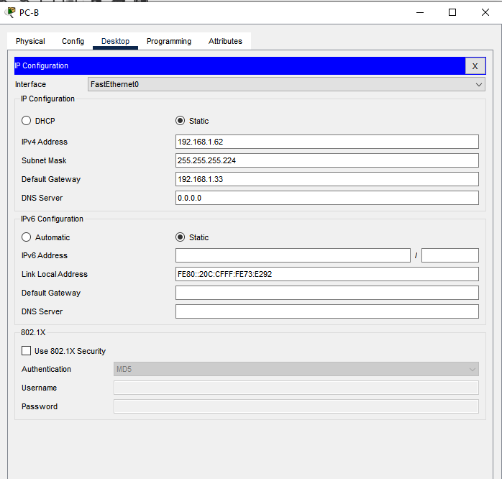

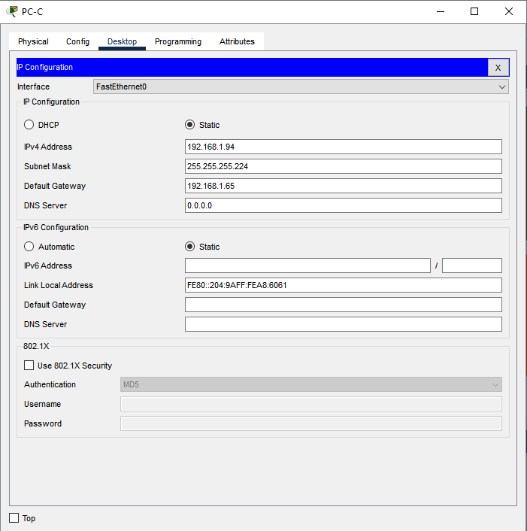
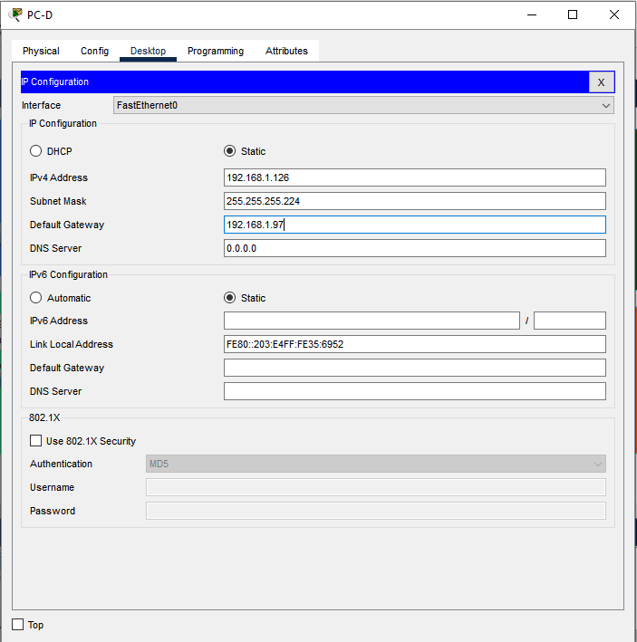

Addressing Table
Devices | Interfaces | IP Addresses | Subnet Mask | Default Gateway
R1 | G0/0/0 | 192.168.1.1 | 255.255.255.0
R1 | G0/0/1 | 192.168.1.33 | 255.255.255.0
R1 | S0/1/1 | 192.168.1.129 | 255.255.255.0
R2 | G0/0/0 | 192.168.1.65 | 255.255.255.0
R2 | G0/0/1 | 192.168.1.97 | 255.255.255.0
R2 | S0/1/1 | 192.168.1.158 | 255.255.255.0
S1 | VLAN1 | 192.168.1.2 | 255.255.255.0
S2 | VLAN1 | 192.168.1.34 | 255.255.255.0
S3 | VLAN1 | 192.168.1.130 | 255.255.255.0
S4 | VLAN1 | 192.168.1.98 | 255.255.255.0
PC-A | NIC | 192.168.1.3 | 255.255.255.0 | 192.168.1.1
PC-B | NIC | 192.168.1.34 | 255.255.255.0 | 192.168.1.33
PC-C | NIC | 192.168.1.66 | 255.255.255.0 | 192.168.1.65
PC-D | NIC | 192.168.1.98 | 255.255.255.0 | 192.168.1.97

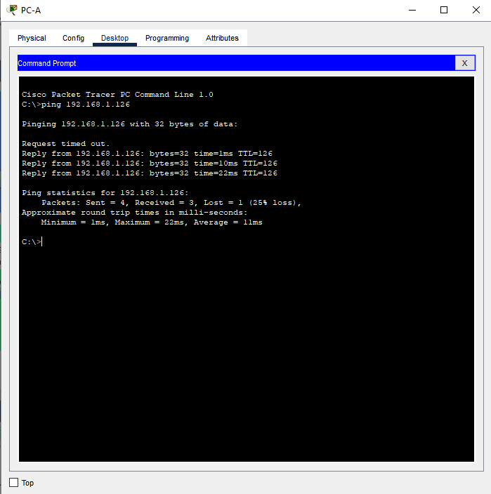
03.Assign IP addresses to network devices and verify connectivity

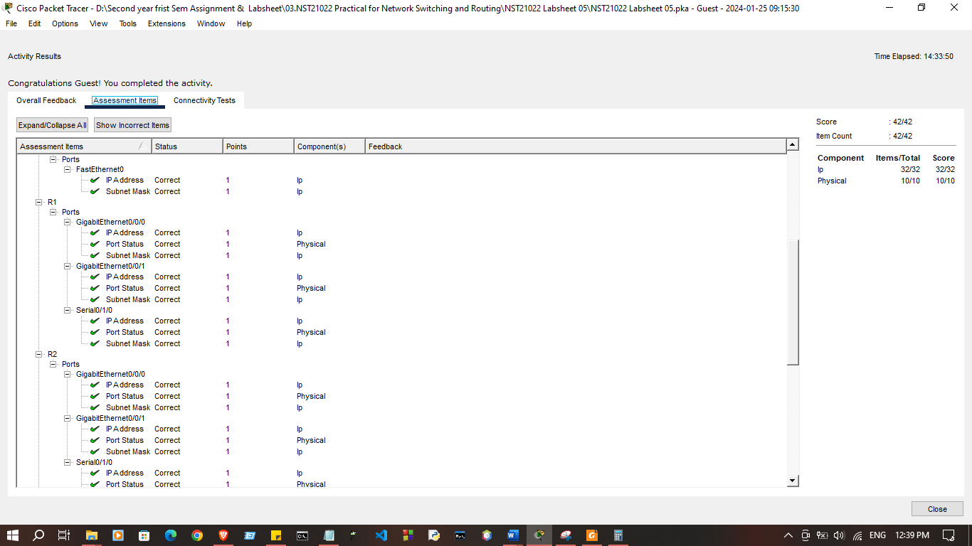

Discussion:

- In this lab session, we focused on understanding IPv4 subnetting and IP addressing schemes. We began by designing an IP scheme, which involved selecting a suitable network address and determining how many subnets and hosts per subnet were required. Next, we performed IPv4 subnetting, breaking down the main network into smaller, more manageable subnets. After creating the subnets, we assigned specific IP addresses to network devices such as PCs, routers, and switches. Finally, we verified connectivity by ensuring that devices could communicate with one another within their subnet as well as across different subnets, confirming that the IP scheme and subnetting were correctly configured. This session helped us grasp the importance of IP addressing and subnetting in efficient network management.

